Barista Coding Challenge

Contents
Overview 1
Setup Instructions: 1
How to run code: 1
Open in STS 2
Improvement opportunities 3

Overview
For this project I decided to code the solution using the Spring Boot framework. I have used this framework recently, but haven’t done much in terms of developing from scratch, so at minimum I decided this would be a good chance to better understand the framework and some of its functionalities as well as how to use it with the command line interface. I specifically decided to try to leverage the JPA repository queries. I felt this helped reduce some redundant methods that pull the same data.
Development Tool: Spring Tool Suite Version: 3.9.1.RELEASE

Setup Instructions:
Source code https://github.com/mreed08/mattsrepository

How to run code:
Download the code from github link above (download zip) and extract the file.
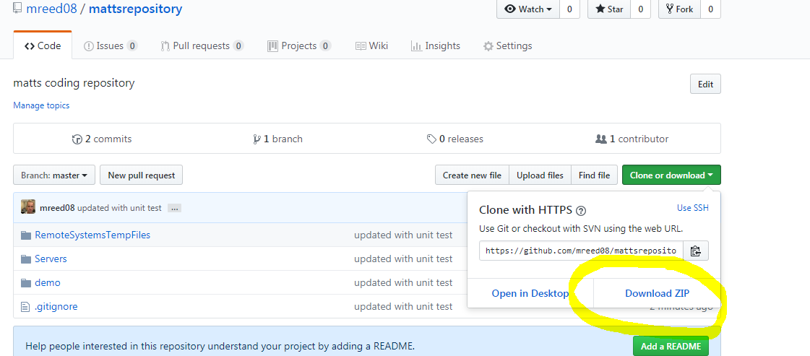
From a command prompt, go to the demo folder from downloaded file
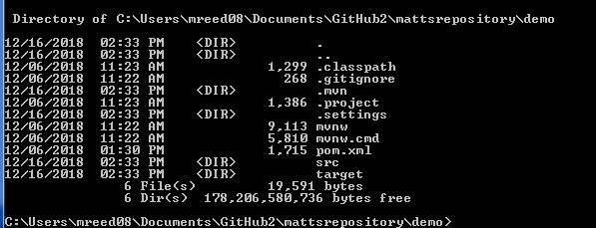

Run Maven Junits and build .jar file type “mvn package install”
Run source Code go to “target” folder and run “java -jar barista-0.0.1-SNAPSHOT.jar”

Open in STS
- File – import – project from Git 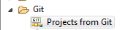
- Select “clone URI”
- Use uri - https://github.com/mreed08/mattsrepository.git
- 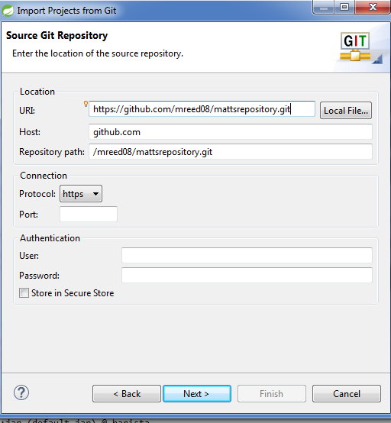
- Select “next” unit project is imported (select any directory you want on your machine)
- Select “import as general project”
- You should now see a project structure like this.
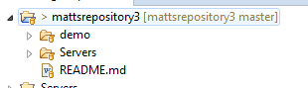
- Right click on “demo” and select “run as” – “run configurations”
- You can model your set up like this, then click “run”, you should then get a console test and build
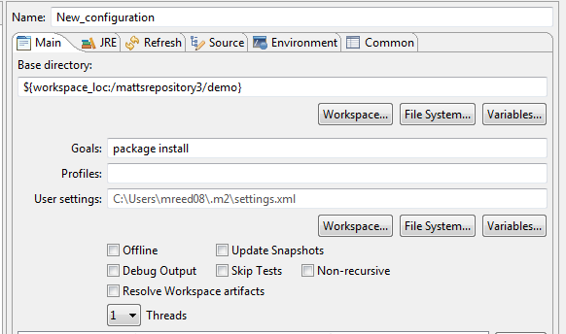
- The final steps in the console will show you were your JAR is built
You would then go to the location of the jar in a command prompt and run
“java -jar barista-0.0.1-SNAPSHOT.jar”

Improvement opportunities
Spring Boot allows loading of data on boot using a schema.sql and data.sql files. I had some issues getting this to work correctly so instead of spending an abundant amount of time on this, I hard coded the saves into the application startup. Due to this, I believe that is why my junit tests were not able to work to load the data while running ‘mvn tests’. My assumption is that it is probably a configuration that is easily fixed but didn’t’ want to again spend more time before returning this to you. (Although I will keep looking for why it won’t work because it is driving me crazy!)
I chose to use only 2 domains instead of adding a “DrinkRecipe” domain which would combine the two domains, but this solution worked and should allow for scaling out new drinks and ingredients without any coding changes.

